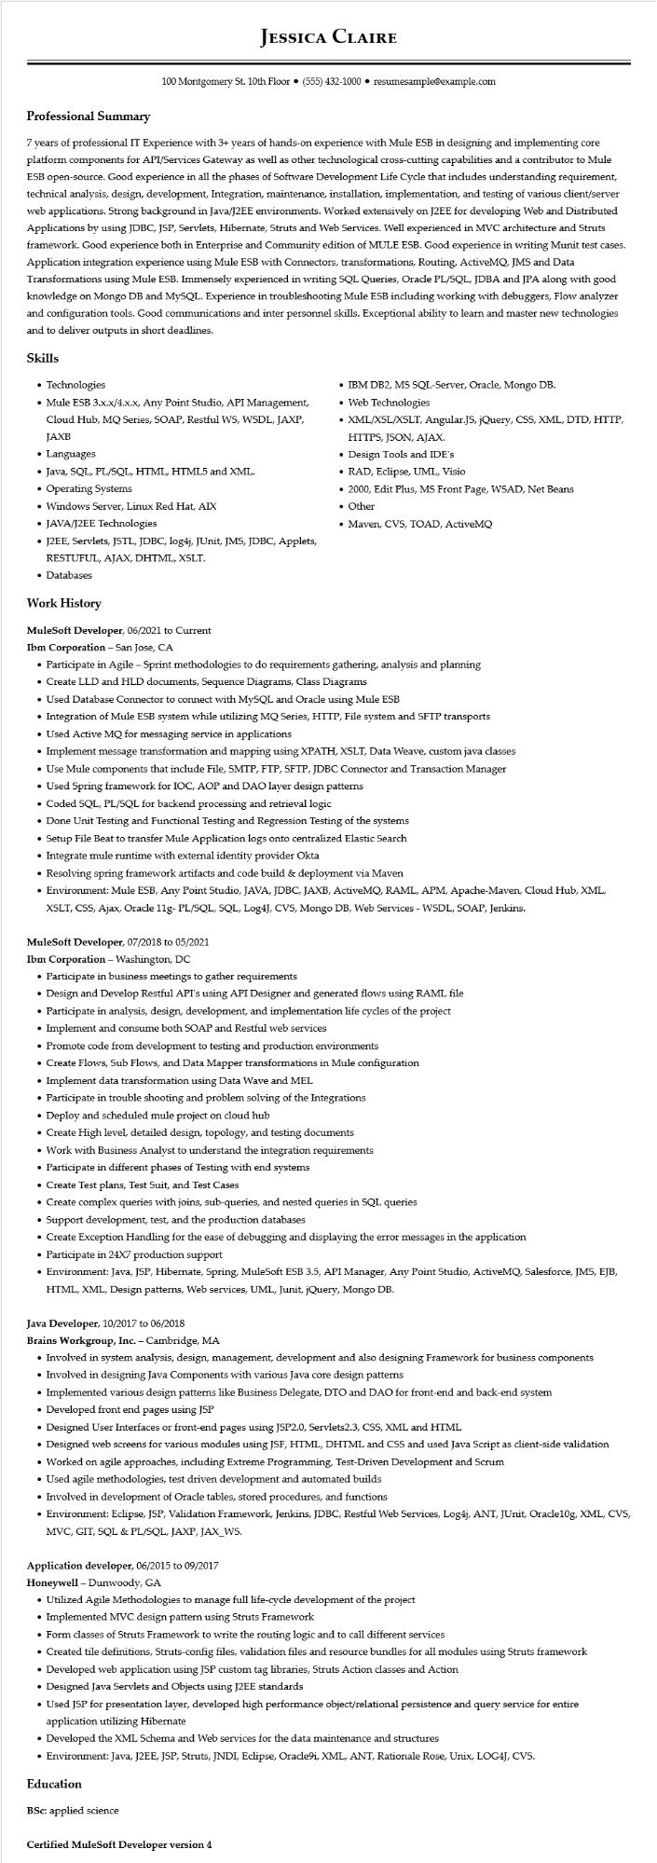
Professional Summary
JESSICA CLAIRE
100 Montgomery St. 10th Floor⚫ (555) 432-1000⚫ resumesample@example.com
7 years of professional IT Experience with 3+ years of hands-on experience with Mule ESB in designing and implementing core platform components for API/Services Gateway as well as other technological cross-cutting capabilities and a contributor to Mule ESB open-source. Good experience in all the phases of Software Development Life Cycle that includes understanding requirement, technical analysis, design, development, Integration, maintenance, installation, implementation, and testing of various client/server web applications. Strong background in Java/J2EE environments. Worked extensively on J2EE for developing Web and Distributed Applications by using JDBC, JSP, Servlets, Hibernate, Struts and Web Services. Well experienced in MVC architecture and Struts framework. Good experience both in Enterprise and Community edition of MULE ESB. Good experience in writing Munit test cases. Application integration experience using Mule ESB with Connectors, transformations, Routing, ActiveMQ, JMS and Data Transformations using Mule ESB. Immensely experienced in writing SQL Queries, Oracle PL/SQL, JDBA and JPA along with good knowledge on Mongo DB and MySQL. Experience in troubleshooting Mule ESB including working with debuggers, Flow analyzer and configuration tools. Good communications and inter personnel skills. Exceptional ability to learn and master new technologies and to deliver outputs in short deadlines.
Skills
• Technologies
• Mule ESB 3.x.x/4.x.x, Any Point Studio, API Management,
Cloud Hub, MQ Series, SOAP, Restful WS, WSDL, JAXP, JAXB
• Languages
• Java, SQL, PL/SQL, HTML, HTML5 and XML.
• Operating Systems
• Windows Server, Linux Red Hat, AIX
• JAVA/J2EE Technologies
• J2EE, Servlets, JSTL, JDBC, log4j, JUnit, JMS, JDBC, Applets,
RESTUFUL, AJAX, DHTML, XSLT.
• Databases
Work History
MuleSoft Developer, 06/2021 to Current
Ibm Corporation - San Jose, CA
• IBM DB2, MS SQL-Server, Oracle, Mongo DB.
• Web Technologies
• XML/XSL/XSLT, Angular.JS, jQuery, CSS, XML, DTD, HTTP, HTTPS, JSON, AJAX.
• Design Tools and IDE's
• RAD, Eclipse, UML, Visio
• 2000, Edit Plus, MS Front Page, WSAD, Net Beans • Other
• Maven, CVS, TOAD, ActiveMQ
• Participate in Agile - Sprint methodologies to do requirements gathering, analysis and planning
• Create LLD and HLD documents, Sequence Diagrams, Class Diagrams
• Used Database Connector to connect with MySQL and Oracle using Mule ESB
• Integration of Mule ESB system while utilizing MQ Series, HTTP, File system and SFTP transports
• Used Active MQ for messaging service in applications
• Implement message transformation and mapping using XPATH, XSLT, Data Weave, custom java classes
• Use Mule components that include File, SMTP, FTP, SFTP, JDBC Connector and Transaction Manager
• Used Spring framework for IOC, AOP and DAO layer design patterns
• Coded SQL, PL/SQL for backend processing and retrieval logic
• Done Unit Testing and Functional Testing and Regression Testing of the systems
• Setup File Beat to transfer Mule Application logs onto centralized Elastic Search
• Integrate mule runtime with external identity provider Okta
• Resolving spring framework artifacts and code build & deployment via Maven
• Environment: Mule ESB, Any Point Studio, JAVA, JDBC, JAXB, ActiveMQ, RAML, APM, Apache-Maven, Cloud Hub, XML, XSLT, CSS, Ajax, Oracle 11g- PL/SQL, SQL, Log4J, CVS, Mongo DB, Web Services - WSDL, SOAP, Jenkins.
MuleSoft Developer, 07/2018 to 05/2021
Ibm Corporation - Washington, DC
• Participate in business meetings to gather requirements
• Design and Develop Restful API's using API Designer and generated flows using RAML file
• Participate in analysis, design, development, and implementation life cycles of the project
• Implement and consume both SOAP and Restful web services
• Promote code from development to testing and production environments
• Create Flows, Sub Flows, and Data Mapper transformations in Mule configuration
• Implement data transformation using Data Wave and MEL
• Participate in trouble shooting and problem solving of the Integrations
• Deploy and scheduled mule project on cloud hub
• Create High level, detailed design, topology, and testing documents
• Work with Business Analyst to understand the integration requirements
• Participate in different phases of Testing with end systems
• Create Test plans, Test Suit, and Test Cases
• Create complex queries with joins, sub-queries, and nested queries in SQL queries
• Support development, test, and the production databases
• Create Exception Handling for the ease of debugging and displaying the error messages in the application
• Participate in 24X7 production support
• Environment: Java, JSP, Hibernate, Spring, MuleSoft ESB 3.5, API Manager, Any Point Studio, ActiveMQ, Salesforce, JMS, EJB, HTML, XML, Design patterns, Web services, UML, Junit, jQuery, Mongo DB.
Java Developer, 10/2017 to 06/2018
Brains Workgroup, Inc. - Cambridge, MA
• Involved in system analysis, design, management, development and also designing Framework for business components
• Involved in designing Java Components with various Java core design patterns
• Implemented various design patterns like Business Delegate, DTO and DAO for front-end and back-end system
• Developed front end pages using JSP
• Designed User Interfaces or front-end pages using JSP2.0, Servlets2.3, CSS, XML and HTML
• Designed web screens for various modules using JSF, HTML, DHTML and CSS and used Java Script as client-side validation
• Worked on agile approaches, including Extreme Programming, Test-Driven Development and Scrum
• Used agile methodologies, test driven development and automated builds
• Involved in development of Oracle tables, stored procedures, and functions
• Environment: Eclipse, JSP, Validation Framework, Jenkins, JDBC, Restful Web Services, Log4j, ANT, JUnit, Oracle 10g, XML, CVS, MVC, GIT, SQL & PL/SQL, JAXP, JAX_WS.
Application developer, 06/2015 to 09/2017
Honeywell - Dunwoody, GA
• Utilized Agile Methodologies to manage full life-cycle development of the project
• Implemented MVC design pattern using Struts Framework
• Form classes of Struts Framework to write the routing logic and to call different services
• Created tile definitions, Struts-config files, validation files and resource bundles for all modules using Struts framework
• Developed web application using JSP custom tag libraries, Struts Action classes and Action
• Designed Java Servlets and Objects using J2EE standards
• Used JSP for presentation layer, developed high performance object/relational persistence and query service for entire application utilizing Hibernate
• Developed the XML Schema and Web services for the data maintenance and structures
• Environment: Java, J2EE, JSP, Struts, JNDI, Eclipse, Oracle9i, XML, ANT, Rationale Rose, Unix, LOG4J, CVS.
Education
BSc: applied science
Certified MuleSoft Developer version 4

